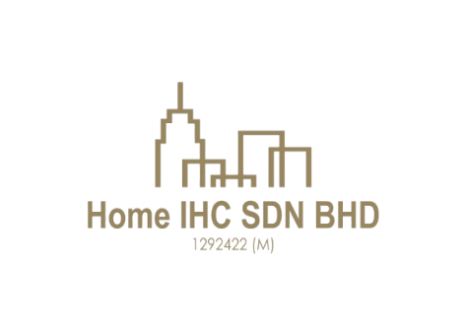
HOME IHC SDN.BHD [201801030396 (1292422-M)]
F-75 Tingkat Atas Jalan Tengku Ismail, 28000 Temerloh Pahang.
(O) 011-630 44931 / 011-100 44931
Email: homeihc22@gmail.com

CUSTOMER PROPERTY VIEWING ACKNOWLEDGEMENT No: 0257

PARTICULARS OF CUSTOMER(S) Date:
☐ MR ☐ MRS ☐ MS  Full Name:  No of pax:  Company Name:  Company Address:  Car plate no:  Tel (Hp):  Called in date:  Refer to:  ☐ I property  ☐ Mudah  ☐ Bentongland Website  ☐ Banner  ☐ Whatsapp  ☐ Facebook | Customer’s request:  Requirement:  Types of Properties:  Property Link:  Location:  Remarks:  Assigned to:  ☐ Co-Broke Partner  ☐ Direct Seller
  ☐ Agricultural Land
  ☐ Commercial Land | ☐ Hotel / Resort
  ☐ Industrial Land | ☐ Factory
  ☐ Residential Land | ☐ Condominium

I/We acknowledge and confirm that I/We have visited and inspected the abovementioned property/properties through the efforts and services provided by Home IHC Sdn. Bhd. (Company No: 1292422-M) and Era Realtor Sdn. Bhd. [E(1)2053/1]. Furthermore, should I/We, my nominee, or a nominated company express interest in purchasing the abovementioned property/properties during the site viewing, it shall still be deemed a sale facilitated by Home IHC Sdn. Bhd. and Era Realtor Sdn. Bhd. [E(1)2053/1]. Should I/We, my nominee, or a nominated company in which I/We have an interest or connection, be interested in purchasing any of the abovementioned property/properties, I/We hereby agree not to negotiate directly with the landlord.

_______________________________ _______________________________
Customer Attended staff/representative
Name: Name: Leong Chu Ping
Date: Date:

Property Proposed/ Viewed Date:

No | Property’s Details | Viewing date | Selling Price | Description
1.
2.

If additions, the submission of documents (eg: title, plans) to the prospective customer,

No | Documents | Qty | Signature | Remarks
1. | - Title  ☐ GM  ☐ GRN  ☐ HSM  ☐ HSD  ☐ Pajakan Mukim  ☐ Pajakan Negeri  ☐ Topo Plan | 1 set |  | ☑ Whatsapp Messenger  ☐ Handover by hardcopy

